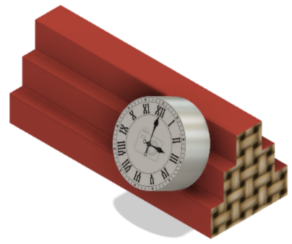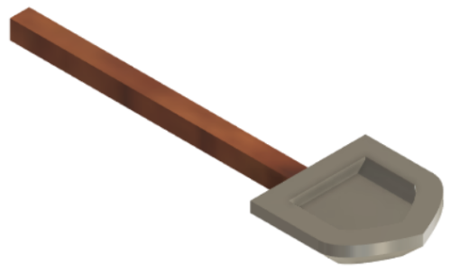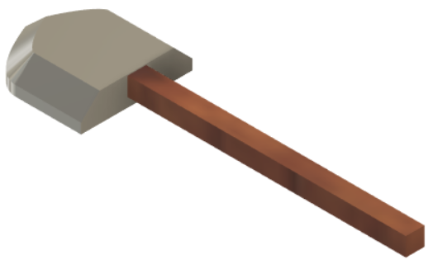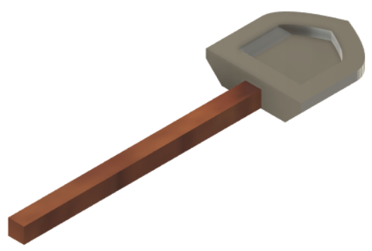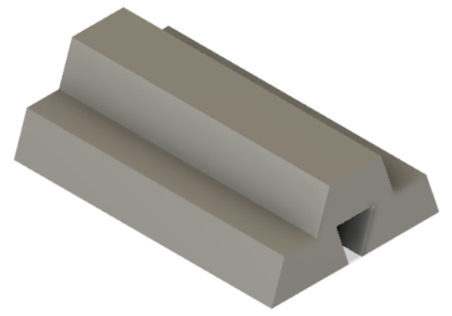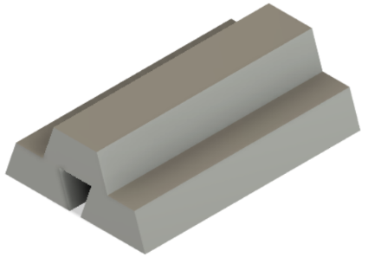

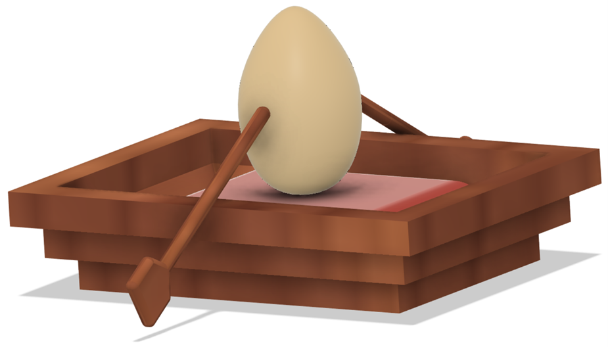

a

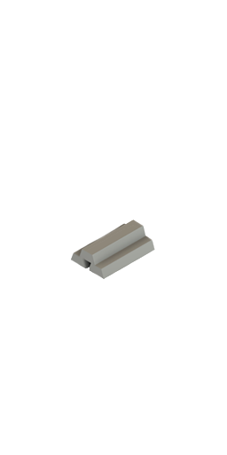

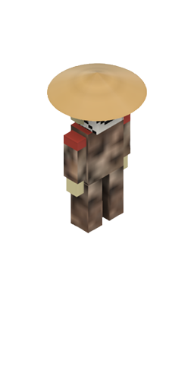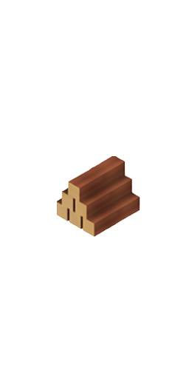**Starting here aree some of the PNGs without background**